FACULTY -BIODATA
Department | Mechanical Engineering ( Poly) |  |  |  |  |  |  |  |  |  |  | 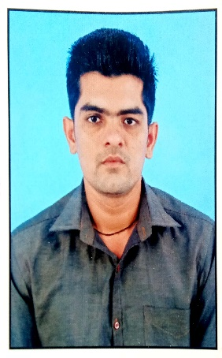
Designation: | Lecturer
Name of Faculty: | Mr. Jagtap Amol Anandrao
Date of Birth: | 27/12/1987 | Date of Joining: |  |  |  | 24/07/2024
Qualification with Class/Grade | UG | PG |  |  |  | Ph.D.
 | First Class | - |  |  |  | -
Area of Specialization:
Total Experience in Years: | Teaching |  |  | Industry |  |  |  |  |  |  | Research
 | 5 |  |  | 01 |  |  |  |  |  |  | -
Mobile No: | 7507077398 |  |  | E-mail ID: |  |  |  |  |  | amoljagtap30@gmail.com
Number of PhD, M.Tech , B.Tech Project Guided | UG: - |  |  |  |  |  | PG: - |  |  |  |  | Ph.D. : -
Professional Society Memberships
Paper Published in Journals | National: - |  |  |  |  |  |  | International: -
Paper Presented in Conferences | National: - |  |  |  |  |  |  | International: -
Books/Chapters/ Patents / Copy rights Published | Books: - | Chapters:- |  |  |  |  |  | Patents: |  |  |  | Copyrights: -
STTPs, FDPs, Workshops attended | STTPs: |  |  |  | FDPs: |  |  |  |  |  | Workshops:
Webinars & Seminars attended | Webinars: |  |  |  |  |  |  |  | Seminars:
STTP, FDP,Webinar& Seminar conducted | STTP: |  | FDP: |  |  |  |  | Seminar: |  |  |  | Webinar:
Resource Person Work Details
NPTEL/Swayam/NITTR/MOOC/ Other courses
Awards/Recognitions
Consultancy Activities | O
Google Scholar Link
Google Site/Website link

Name & Signature of Faculty

