FACULTY -BIODATA
Department | Mechanical Engineering ( Poly) |  |  |  |  |  |  |  |  |  |  | 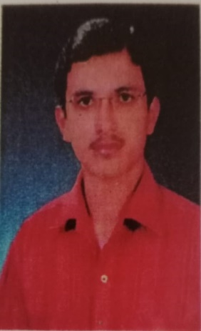
Designation: | Lecturer
Name of Faculty: | Mr. Patil Swapnil Jaywant
Date of Birth: | 19/08/1987 | Date of Joining: |  |  |  | 02/09/2024
Qualification with Class/Grade | UG | PG |  |  |  | Ph.D.
 | Second Class | First Class |  |  |  | -
Area of Specialization: | Mechanical Design
Total Experience in Years: | Teaching |  |  | Industry |  |  |  |  |  |  | Research
 | 10 |  |  | 04 |  |  |  |  |  |  | -
Mobile No: | 8984520999 |  |  | E-mail ID: |  |  |  |  |  | raj.patil009@gmail.com
Number of PhD, M.Tech , B.Tech Project Guided | UG: 12 |  |  |  |  |  | PG: - |  |  |  |  | Ph.D. : -
Professional Society Memberships | 01
Paper Published in Journals | National: - |  |  |  |  |  |  | International: -02
Paper Presented in Conferences | National: -08 |  |  |  |  |  |  | International: -02
Books/Chapters/ Patents / Copy rights Published | Books: - | Chapters:- |  |  |  |  |  | Patents: |  |  |  | Copyrights: -
STTPs, FDPs, Workshops attended | STTPs: 02 |  |  |  | FDPs: 01 |  |  |  |  |  | Workshops: 04
Webinars & Seminars attended | Webinars: |  |  |  |  |  |  |  | Seminars:
STTP, FDP,Webinar& Seminar conducted | STTP: |  | FDP: |  |  |  |  | Seminar: |  |  |  | Webinar:
Resource Person Work Details
NPTEL/Swayam/NITTR/MOOC/ Other courses | 04
Awards/Recognitions
Consultancy Activities | O
Google Scholar Link
Google Site/Website link

Name & Signature of Faculty

